**TITLE OF ARTICLE**

**(Capital letters, Times New Roman, 14, bold, followed by 1 emply line)**

**Author's name_1**

**(Times New Roman, font size 12, bold)**

*Academic ranking, Institutional affiliation (Times New Roman, font size 10, italic)*

*Address: 3515 Miskolc, Miskolc-Egyetemváros, e-mail:* [*hgzb@uni-miskolc.hu*](mailto:hgzb@uni-miskolc.hu)

**Repeat this section for all authors**

***Abstract (Times New Roman, font size 11, bold italic)***

*The article starts with a short (max. 8-10 rows) summary of the paper's content. Please follow the instructions (styles of headings, pharagraphs, lists, etc.) included in this template when preparing your manuscript. For your convenience, the font name, size and style to be applied for the given section are listed and highlighted in yellow. These should be necessarily removed from your final paper …(Times New Roman, font size 11, italic)*

***Keywords:*** *3-5 specific keywords that directly relate to this research topic .…(Times New Roman, font size 11, italic)*

1. **Introduction (Style: Heading 1, Times New Roman, 12, bold)**

The minimal length of the paper is 8 pages. The first text body paragraph after each heading should be written without indentation. (Style: Times New Roman, font size 11, normal).

Any further text body paragraphs start with the first line indented by 0.5 cm. Paragraphs are not delimited by empty lines. (Style: Times New Roman, font size 11, normal, first line indented).

In the text body lists can be created using numbering or any types of bullets. Their format is specified as follows:

1. numbered lists should have first line indented (Style: numbered list, justified left: 0.5 cm, indent: 0.5 cm, font: Times New Roman, size 11);
2. the size of first line indentation is the same as in text body paragraphs;
3. lists can be numbered or marked with any types of bullets (list indent left 0.5 cm, hanging indent 0.5 cm)

The next paragraph shows an example for bulleted lists. Any types of bullet characters are allowed, but they should be used consequently throughout a paragraph. For example: (Times New Roman, 11)

* Page settings
  + Page size: A4, portrait
  + Type area (size of text area within an A4 size page): 130×195 mm
  + Margins
  + Top: 2.5 cm, Bottom: 2.5 cm
  + Left: 2.5 cm, Right: 2.5 cm (the use of these margins yields the specified type area).

These page settings need to be strictly followed for the sake of uniform outlook of the papers. This is the basic requirement of a camera ready manuscript. The magnification of papers following this specification will not be changed, i. e. the final version will absolutely match the format of the manuscript.

* 1. **Using subtitles (Sublevel 2, style: Heading 2; font size: 12 pt)**

Throughout the document the *Multilevel numbered list* template with decimal numbering should be applied for headings. It is not recommended to use more than 3 sublevels in headings.

* + 1. ***Inserting tables (Sublevel 3, stlye: Heading 3, font size: 11pt)***

Tables need to be aligned center (Times New Roman, font size 11; table number: italic, bold; table caption: italic.) Table number and caption should be placed above the table right justified, keeping 6pt vertical space both from the preceding text and the following table. The table should be followed by a linefeed.

***Table 1.*** *Table caption*

|  | k [m/d] | q [m3/mּd] | Q [m3/d] |
| --- | --- | --- | --- |
| 1. case | 0.00086 | 0.0023 | 11.575 |
| 2. case | 0.0864 | 0.2257 | 56.425 |
| 3. case | 0.0764 | 0.1996 | 49.912 |

Table caption and body should be kept together. When inserting longer tables avoid their splitting too, i. e. all table rows should remain on the same page. The size of text in table cells is preferably the same as the font size of Text Body. It it is not possible because of the table's complexity, do not use smaller font size than 10pt to keep the text legible. Depending on the type of data in table cells, apply center or right justification. Be aware, that table width should be within the type area.

* + 1. ***Formulas***

Mathematical formulas should be composed using either the built-in equation editor of Word, or the MathType add-in for Office that is specifically made for writing scientific formulas (the latter is prefered).

(1)



Formulas should be aligned center, while their numbering should be given right justified below the formula. In this template file the MathType formula editor was used with font size 11pt. To get the same result, do not forget to set Full to 11pt in the MathType menu. The other settings are automatic in MathType.

* + 1. ***Inserting figures***

Figures need to be aligned center. It is recommended to insert only high quality figures edited by a computer program, or high quality photos.

Figure captions should use automatic numbering. Figure number: Times New Roman, font size 11, bold, italic. Figure caption: italic. Figures should be referred from text with automatic Cross-reference. The size of text on figures (e.g. axis labels, legend) should be adjusted to the size of the figure keeping the rules of legibility. When preparing figures – especially in the case of color figures – pay special attention to choosing appropriate line width and colors.

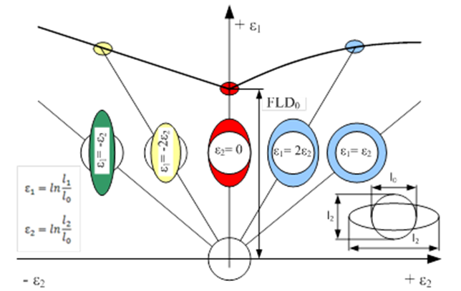

***Figure 1.*** *Forming limit diagram. (Times New Roman, font size 11, italic)*

For the purpose of illustration, only high quality contrasted pictures can be inserted in the paper. Their captions should use automatic numbering according to and continuing the numbering of figures. Figures should be positioned as close to the referring text as possible.

1. **Summary (Style: Heading 1)**

The paper ends up with the summary of the most important results and conclusions. This should not be identical with the paper's abstract word-for-word. The purpose of the abstract is to draw the readers' attention by shortly summarizing the main points of the paper's content. On the other hand, the Summary at the end contains the review of the results and conclusions beside the content summary.

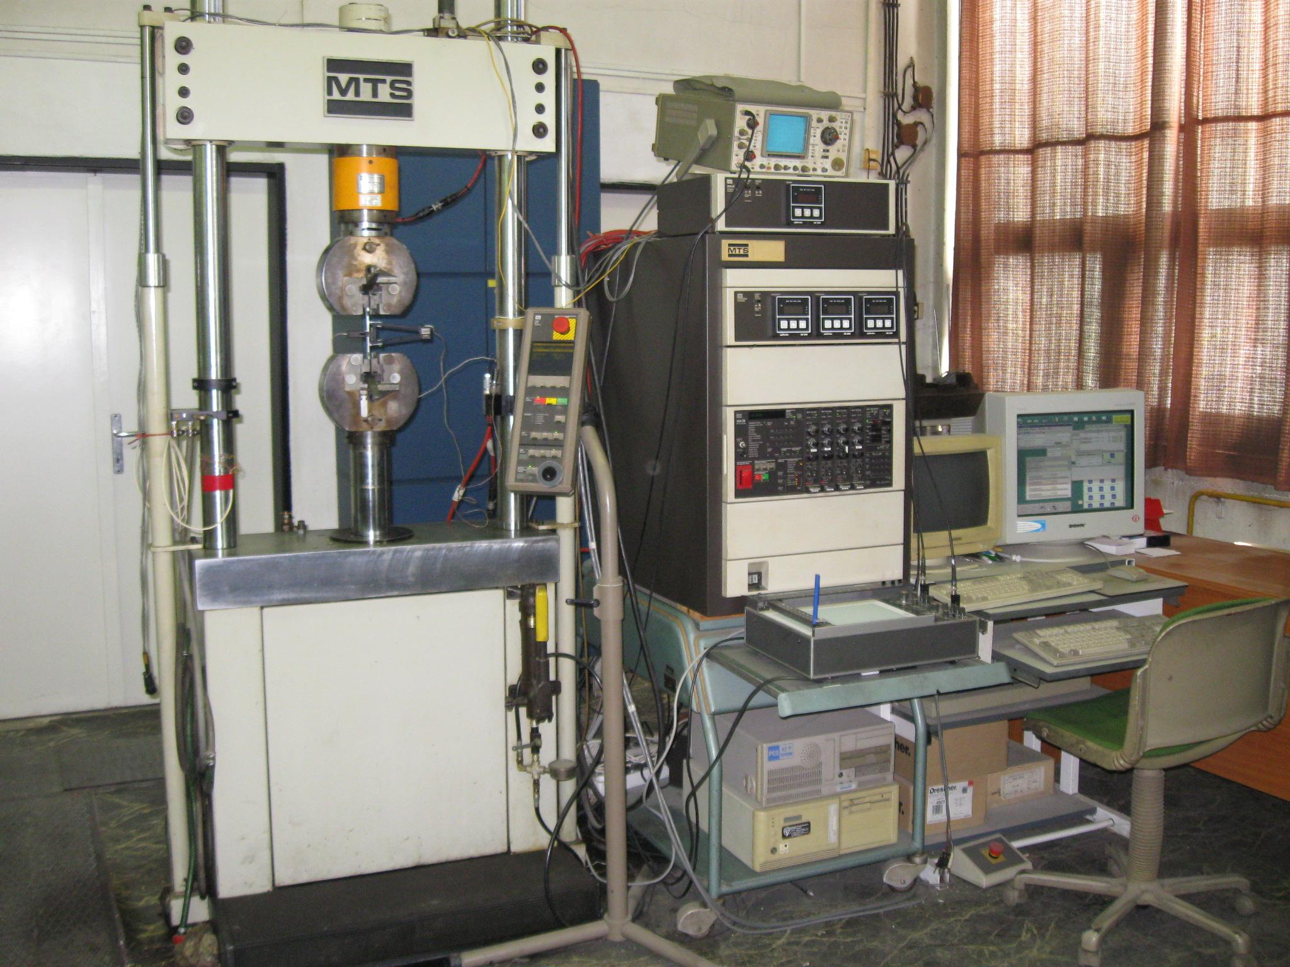

***Figure 2.*** *MTS electrohydraulic material testing system*

1. **Acknowledgements (Style: Heading 1)**

The research reported here was carried out as part of the EFOP-3.6.1-16-2016-00011 “Younger and Renewing University – Innovative Knowledge City – Institutional development of the University of Miskolc aiming at intelligent specialization” project implemented in the framework of the Szechenyi 2020 program. The realization of this project is supported by the European Union, co-financed by the European Social Fund.

**References** (Times New Roman, font size 12, bold)

1. Sapolsky, R. M. (2017). Behave: *The biology of humans at our best and worst*. Penguin Books.
2. Dillard, J. P. (2020). Currents in the study of persuasion. In M. B. Oliver, A. A. Raney, & J. Bryant (Eds.), *Media effects: Advances in theory and research* (4th ed., pp. 115–129). Routledge.
3. Grady, J. S., Her, M., Moreno, G., Perez, C., & Yelinek, J. (2019). Emotions in storybooks: A comparison of storybooks that represent ethnic and racial groups in the United States. *Psychology of Popular Media Culture*, *8*(3), 207–217. **https://doi.org/10.1037/ppm0000185**
4. Bologna, C. (2019, October 31). *Why some people with anxiety love watching horror movies*. HuffPost. https://www.huffpost.com/entry/anxiety-love-watching-horror-movies_l_5d277587e4b02a5a5d57b59e
5. Jayatilleka, S., Okogbaa, G.: *Accelerated Life Testing*, 2014 Workshop on Accelerated Stress Testing and Reliability Conference, Saint Paul, Minnesota, Egyesült Államok, pp. 1-21.

In text citation:

(Sapolsky, 2017) or in the case of more authors (Grady et al., 2019)